Intel Wonders Volunteering project: Create educational material for kids/young-adults to expose them to new technologies. Working together with the Rashi Foundation – Cyber Educational Center – in Israel, who are focusing on kids/young-adults from the peripheries of the country, giving them an additional edge toward higher education in the technological fields: computer science and hardware engineering.

פרוייקט התנדבות לכבוד חגיגות 50 לאינטל: יצירת חומרי הדרכה לילדים ונוער בשיתוף עם קרן רש״י. הקרן עובדת עם ילדים ובני נוער מהפריפריה בישראל והכנתם ליחידות טכנולוגיות.

We focused on two age groups and built material that are aimed toward them:

1. For kids in grade 5-7 we provide a 1-2-hour educational material. Expose to computer structure and early engagement with micro controllers.
2. For young female adults’ grade 10-12 we provide a full day educational material. Experience with game programing and AI.

הפרוייקט כלל שני חלקים:

1. לילדים בכיתות ה׳-ז׳ הדרכה קצרה בנושא הכרות עם מבנה המחשב. הרכבת מחשב מיני והורדת משחק להתנסות כיפית.

2. לבנות נוער בכיתות י׳-י״א׳ הדרכה של יום שלם בלימוד יצירת משחק ושילוב של בינה מלאכותית.

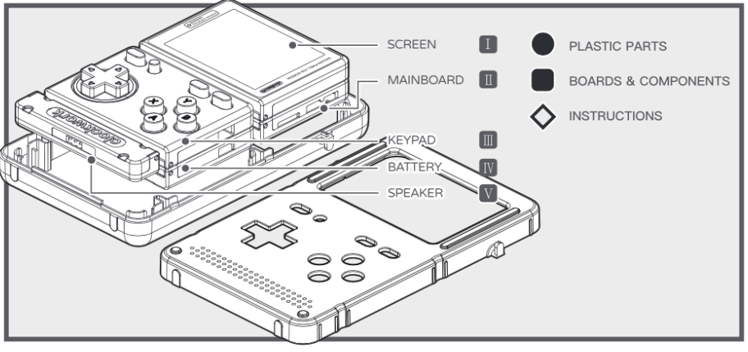Introduction to computer structure: the focus on this education is on understanding the fundamental building blocks of modern computer. This is achieved by building a tiny computer called the GameShell: <https://www.clockworkpi.com> – we provide the kids with disassembled parts, teach them about each part and its usage in a computer. The kids then assembles the kit into a fully functioning computer. Later on, the kids connects the device through Wifi and download an example game that they can launch and play on the device. In the future, the Rashi Foundation are planning to use GameShell for more advance educational courses, such as learning to program, using the device with external inputs/outputs, etc…

Introduction to Game programming and Artificial Intelligent: Together with the foundation we decided to focus this course on young adult with some background in programming from earlier grades in school. The course is based on the Unity development environment: <https://unity3d.com>, which is a multi-platform development environment for games.

The educational material provides early understanding of gaming development, introduction to artificial intelligent and even a brief touch on genetic algorithm and neural networks.

The young-adults will learn to build a “flappy bird” style game. Once they achieve this goal, they will move to creating an interface for AI to control the game instead of the user, initially building a simple AI algorithm. Later on, they will receive introduction to genetic algorithm and neural networks, they will start with a ready-made simple library that provides these codes and will integrate them into the game. Exploring AI learning for themselves. For motivate, the material also provides real life examples of where AI is used today and in the future and the benefits it brings.

